DRAFT 1.0

STATISTICS

What is Statistics?

It is a branch of science whose remit involves the enqire in to the state of some entity. This involves the application of the scientific method as illustrated in the figure below.

Identification

Formulation

Model

Test & Validate

Implement

Statistics is the science of uncertainty. It gives a scientific and hence a rational methodology to understand variability. Elements in statistics are :

- Information Collection

- Information Summaries

- Information Analysis

- Information Modelling

- Information Inferences

- Information Forecasting

Information can be pictures, words, music, electrical signals or numbers. The use of numbers is the most familiar in statistics, this type of quantitative data can be classified as variables or attributes.

Variables are continuous measurements like weight, height or speed or discrete variables like number of children per family or number of cars owned. Attribute data is simply a recording of a state, for example married or single, or defective - non defective. Attribute data can also be expressed as counts of the numbers in different states, for example the number of things wrong with a new house.

Why Use Statistics?

There is a need to:

i. Know how the process is performing.

ii. If improvements are worthwhile.

Statistics provides a methodology for this, specifically statistics allows one to:

• collect data

• measure

• summarise

• identify relationships

• make inferences and predict

• facilitate communication

The application of statistics makes for timely, efficient and accurate investigation and reporting.

Statistics has been described as a "vital business tool" and Cristoforio (1987) states that:

"Words can't describe quality - only statistics can"

Edward Deming in his 1986 book out of the crises states:

“Statistics is the science of variation and is the only way to truely understand quality”

What is Variation?

Everything varies and the greater this variation the greater the uncertainty. The aim in quality is to first identify the amount of variation, then control it to acceptable bounds and then reduce variation and hence improve.

How Does Variability Come About?

Everything varies: no two components or services are precisely the same - if measured sufficiently accurately there are always differences. These natural variances are greatly inflated when humans interfere to try and make things. Many factors impinge on the production system to increase natural variability, such as economic and environmental fluctuations, peoples' state of health and emotions, raw materials used, condition of equipment used and so forth.

Variability exists everywhere :

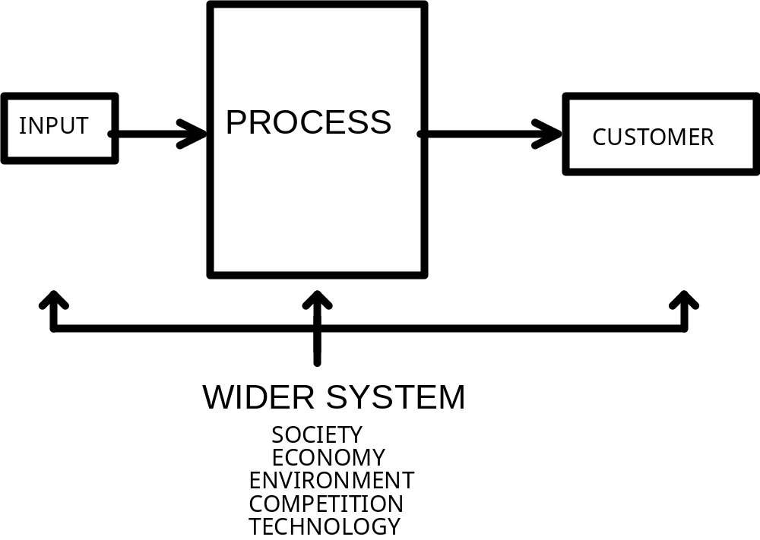

For the processes that you are involved with list six things that can vary and how this variability can be detected:



Types of Variation

Varriation can be classified into two types assignable causes and common causes. In assignable causes variation, usually excessive, can be attributed a reason such as a machine is broken, a photocopier is low on toner, or extreme weather conditions. Often assignable cause variation can be dealt with easily. Common cause variation is harder to reduce and is the natural or background variation of the process. To reduce this long sustained adoption of quality methods and management commitment is required.

The aim is to reduce this variability and produce consistency and make the process ROBUST to the inherent variation. It is precision rather than accuracy that is required. Consider the performance of the following two sharp shooters - who has the best long term prospect and why?

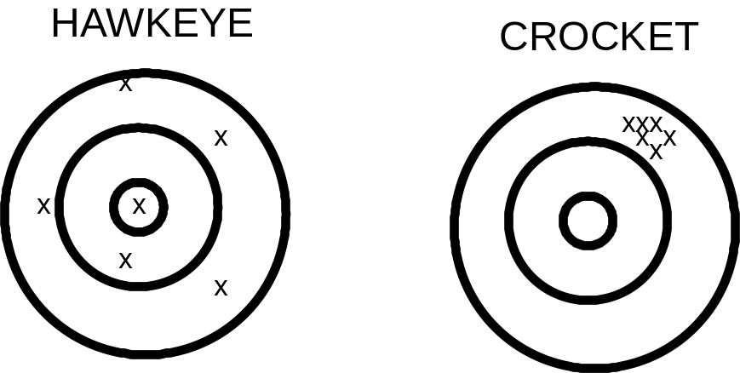

Statistics is a "tool" used to obtain robustness and precision.

There is an over riding principle that one should remember - simple methods are best. Not only are they often the most appropriate but simple methods are more believable, understandable and easiest to communicate. The Americans call this the KISS principle

KEEP IT SIMPLE STUPID

This Course

The course has been designed to give an awareness usefulness of various statistical tools that may be of help to you at your work. It is by no means comprehensive but most of the main day to day methods are covered. The cousre will begin with the assumption that you have collected data and some tools for presenting this and summarising it will be given. The concept of probability will then be outlined and some useful distributions descibed. This will then allow the consideration of confidence in estimates and judgements made to the significance of differences. After this we will then consider the ealier stage of data collection and methods of enhancung accuracy in decision making. On from this a review of tools particulary helpful in the improvement of quality will be preseneted and the course will finish with an overview of the concepts of correlation and regression.

The course notes are just notes and full treatments of the topics are to be found in the texts listed at the end of the notes.

CHAPTER TWO

Data Presentation and Summaries

GRAPHICAL TOOLS ARE VERY HELPFUL IN IDENTIFYING PROBLEMS

SCATTER PLOTS

Simple plots can be very useful in identifying relationships. For example is there a relationship between temperature and the percentage of prepacked food failing a bacteria incubation test.

Temperature 27 30 31 32 32 32.5 32.5 32.5 33 33 33
% failing 1 4 7.5 8 4.5 7 5 9 11 13 11

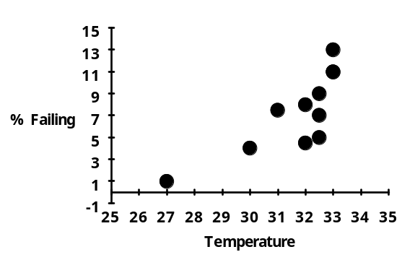

So the percentage failing and temperature do seem to be related - they are said to be positively correlated.

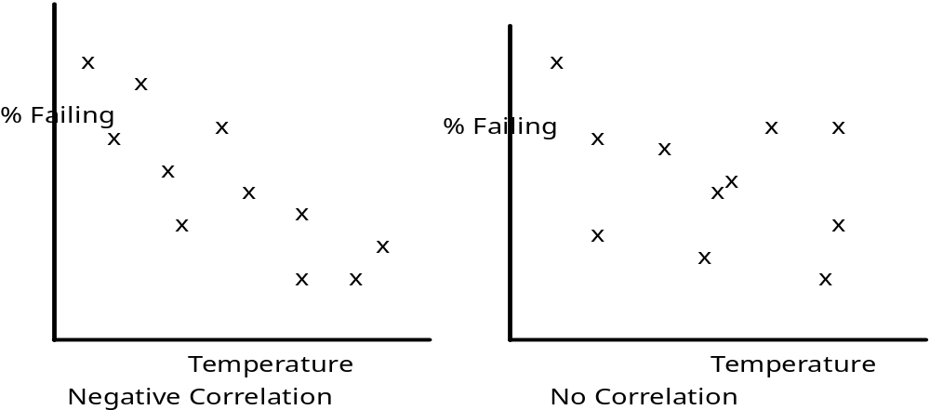
RUN PLOTS

These are very useful for identifying trends, like for
example the temperature in a controlled room over a 65 day period:

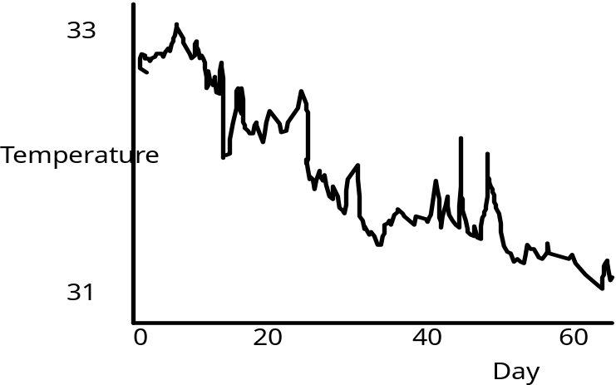

There appears to be a gradual downwards drift (trend).

Run plots are also useful for identifying assignable causes, for example, consider the following year weekly total defects in sending invoices:

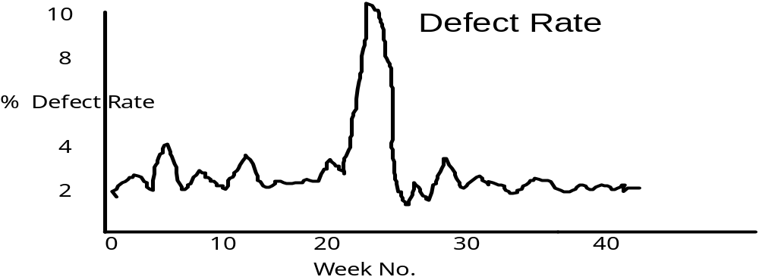

What could be the reasons for the dramatic rise in the defect rate?
PIE CHARTS AND BAR CHARTS

These are useful for displaying attribute data. For example consider a survey of 155 cars manufactured in three countries. The distribution of these cars by country of origin is shown in the following diagrams:

Pie Chart of Origin of Cars
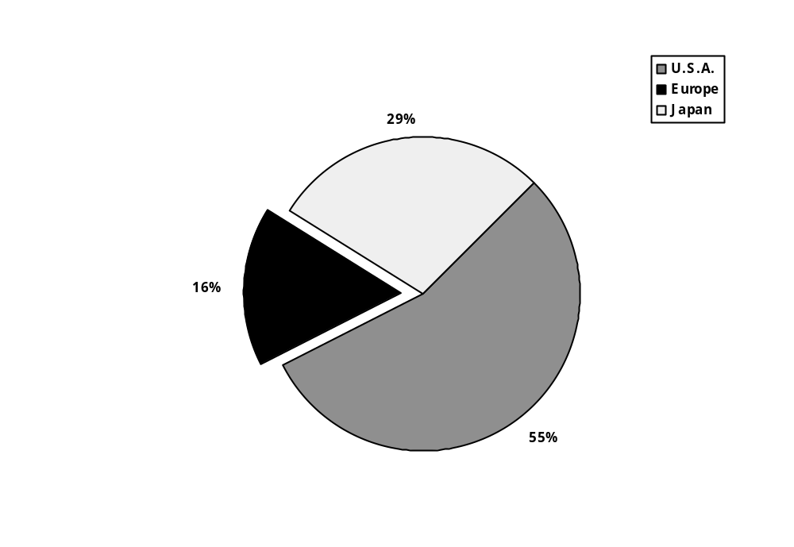

Bar Chart of Origin of Cars

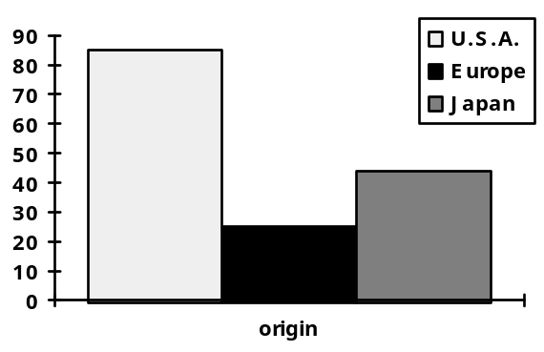

The pie chart looks nice, but it is hard to construct and is not nearly as informative as the bar chart. The more categories then the more appropriate bar charts become.

In the next chapter more formal ways of picturing data is described. In addition to this numerical summaries of data are outlined and the methodology of exploratory data analysis is introduced.

Data Summaries

Graphical

In this chapter pictorial and numerical summaries of data will be described and the chapter will end by outlinnig the powerful technique of Exploratory Data Analysis.

When describing data the key pieces of information to convey are their LOCATION and SPREAD. By LOCATION one means location on the number line, for example the numbers 5, 3, 4, 2, 8, 4 are located at different place from the numbers 100 110, 90, 98, 130.

SPREAD is a critical measure for qualty - it is a measure of the data's variability. The larger the spread, the greater the variability and so, in quality terms, the poorer the performance.

Thus to compare a process at different time or with other processes it is necessary to have measures of the location and spread of the associated data.

Consider the following three data sets of miles per gallon of American, European and Japanese cars recorded as part of a survey in 1987. The data is :

Row mpg make origin model price
1 43.1 Volkswagen 2. Rabbit Dl 2400.
2 36.1 Ford 1. Fiesta 1900.
3 32.8 Mazda 3. GLC Deluxe 2200.
4 39.4 Datsun 3. B210 GX 2725.
5 36.1 Honda 3. Civic CVCC 2250.
6 19.9 Oldsmobile 1. Cutlass 3300.
7 19.4 Dodge 1. Diplomat 3125.
8 20.2 Mercury 1. Monarch 2850.
9 19.2 Pontiac 1. Phoenix 2800.
10 20.2 Ford 1. Fairmont A 2375.
12 25.1 Ford 1 2700.
14 19.4 AMC 1. Concord 2300.
15 20.6 Buick 1. Century 3300.
16 20.8 Mercury 1. Zephyr 2425.
17 18.6 Dodge 1. Aspen 2700.
18 18.1 AMC 1. Concord D1 2425.
19 19.2 Chevrolet 1. MonteCarlo 3900.
20 17.7 Buick 1. RegalTurbo 4400.
21 18.1 Ford 1. Futura 2525.
22 17.5 Dodge 1. Magnum XE 3000.
23 30.0 Chevrolet 1. Chevette 2100.
24 27.5 Toyota 3. Corona 2975.
25 27.2 Datsun 3. 510 2775.
26 30.9 Dodge 1. Omni 2250.
27 21.1 Toyota 3. Celica GT 3700.
28 23.2 Plymouth 1. Sapporo 3200.
29 23.8 Oldsmobile 1. Starfire 2400.
30 23.9 Datsun 3. 200-SX 2975.
31 20.3 Audi 2. 5000 4475.
32 17.0 Volvo 2. 264GL 5875.
33 21.6 Saab 2. 99GLE 4200.
34 16.2 Peugeot 2. 604SL 5450.
35 31.5 Volkswagen 2. Scirocco 3675.
36 29.5 Honda 3. Accord LX 3425.
37 21.5 Pontiac 1. Lemans V6 3925.
38 19.8 Mercury 1. Zephyr 6 3200.
39 22.3 Ford 1. Fairmont 2975.
40 20.2 AMC 1. Concord 3150.
41 20.6 Dodge 1. Aspen 6 3325.
42 17.0 Chevrolet 1. Caprice Cl 4650.
43 17.6 Ford 1. LTD Landau 4850.
44 16.5 Mercury 1. GrandMarqs 5725.
45 18.2 Dodge 1. St. Regis 4025.
46 16.9 Buick 1. Estate SW 5225.
47 15.5 Ford 1. Country SW 4825.
48 19.2 Chevrolet 1. Malibu SW 4100.
49 18.5 Chrysler 1. Lebaron SW 4725.
50 31.9 Volkswagen 2. Rabbit Cus 3100.
51 34.1 Mazda 3. GLC Deluxe 2750.
52 35.7 Dodge 1. Colt Hatch 2700.
53 27.4 AMC 1. Spirit DL 2725.
54 25.4 Mercedes 2. 300D 15475.
55 23.0 Cadillac 1. Eldorado 9900.
56 27.2 Peugeot 2. 504 4675.
57 23.9 Oldsmobile 1. Cutlass 4050.
58 34.2 Plymouth 1. Horizon 2625.
59 34.5 Plymouth 1. HorizonTC3 2775.
60 31.8 Datsun 3. 210 2750.
61 37.3 Fiat 2. Strada Cus 2275.
62 28.4 Buick 1. SkylarkLim 3525.
63 28.8 Chevrolet 1. Citation 3625.
64 26.8 Oldsmobile 1. Omega 3525.
65 33.5 Pontiac 1. Phoenix 3325.
66 41.5 Volkswagen 2. Rabbit 7000.
67 38.1 Toyota 3. CorollaTer 3850.
68 32.1 Chevrolet 1. Chevette 2900.
69 37.2 Datsun 3. 310 3525.
70 28.0 Chevrolet 1. Citation 3625.
71 26.4 Ford 1. Fairmont 3525.
72 24.3 AMC 1. Concord 3625.
73 19.1 Dodge 1. Aspen 3700.
74 34.3 Audi 2. 4000 5900.
75 29.8 Toyota 3. Corona LB 5500.
76 31.3 Mazda 3. 626 4675.
77 37.0 Datsun 3. 510 Hatch 4050.
78 32.2 Toyota 3. Corolla 3975.
79 46.6 Mazda 3. GLC 3350.
80 27.9 Dodge 1. Colt 3200.
81 40.8 Datsun 3. 210 3300.
82 44.3 Volkswagen 2. Rabbit Dl 3900.
83 43.4 Volkswagen 2. Dasher Dl 3825.
84 36.4 Audi 2. 5000S Dl 7975.
85 30.4 Mercedes 2. 240D 14275.
86 44.6 Honda 3. Civic1500G 3925.
87 40.9 Renault 2. LeCar Delx 2575.
88 33.8 Subaru 3. DL 3625.
89 29.8 Volkswagen 2. Rabbit 7000.
90 32.7 Datsun 3. 280-ZX 8150.
91 23.7 Mazda 3. RX-7 GS 7250.
92 35.0 Triumph 2. TR7 Coupe 5000.
93 23.6 Ford 1. Must Cobra 4250.
94 32.4 Honda 3. Accord 4700.
95 27.2 Plymouth 1. Reliant 5100.
96 26.6 Buick 1. Skylark 5175.
97 25.8 Dodge 1. Aries SW 4950.
98 23.5 Chevrolet 1. Citation 4550.
99 30.0 Plymouth 1. Reliant 4900.
100 39.1 Toyota 3. Starlet 4400.
101 39.0 Plymouth 1. Champ 3600.
102 35.1 Honda 3. Civic1300 4000.
103 32.3 Subaru 3. 3950.
104 37.0 Datsun 3. 210 3775.
105 37.7 Toyota 3. Tercel 4475.
106 34.1 Mazda 3. GLC 4 3975.
107 34.7 Plymouth 1. Horizon 4 3450.
108 34.4 Ford 1. Escort 4W 3850.
109 29.9 Ford 1. Escort 2H 4100.
110 33.0 Volkswagen 2. Jetta 5650.
111 34.5 Renault 2. 18I 4600.
112 33.7 Honda 3. Prelude 5550.
113 32.4 Toyota 3. Corolla 4650.
114 32.9 Datsun 3. 200SX 5825.
115 31.6 Mazda 3. 626 5650.
116 28.1 Peugeot 2. 505S Dl 8500.
117 Saab 2. 900S 8225.
118 30.7 Volvo 2. Diesel 8550.
119 25.4 Toyota 3. Cressida 9475.
120 24.2 Datsun 3. 810 Maxima 8375.
121 22.4 Buick 1. Century 6675.
122 26.6 Oldsmobile 1. Cutlass LS 6875.
123 20.2 Ford 1. Granada GL 5450.
124 17.6 Chrysler 1. Lebaron 5625.
125 28.0 Chevrolet 1. Cavalier 5275.
126 27.0 Chevrolet 1. CavalierSW 5500.
127 34.0 Chevrolet 1. Cavalier2D 5175.
128 31.0 Pontiac 1. 1200 Hatch 5650.
129 29.0 Dodge 1. Aries SE 6250.
130 27.0 Pontiac 1. Phoenix 5650.
131 24.0 Ford 1. Fairmont 5225.
132 23.0 AMC 1. Concord Dl 5150.
133 36.0 Volkswagen 2. Rabbit L 5200.
134 37.0 Mazda 3. GLC Cust l 4900.
135 31.0 Mazda 3. GLC Custom 5100.
136 38.0 Plymouth 1. Horizon 4350.
137 36.0 Mercury 1. Lynx l 4550.
138 36.0 Nissan 3. Stanza XE 6350.
139 36.0 Honda 3. Accord 6500.
140 34.0 Toyota 3. Corolla 5425.
141 38.0 Honda 3. Civic M 4625.
142 32.0 Honda 3. Civic A 4875.
143 38.0 Datsun 3. 310 GX 5075.
144 25.0 Buick 1. CenturyLmt 7300.
145 38.0 Oldsmobile 1. Cutlass Dl 7450.
146 26.0 Chrysler 1. Lebaron 6000.
147 22.0 Ford 1. Granada l 6100.
148 32.0 Toyota 3. Celica GT 7700.
149 36.0 Dodge 1. Charger2.2 5475.
150 27.0 Chevrolet 1. Camaro 8400.
151 27.0 Ford 1. MustangGL 5975.
152 44.0 Volkswagen 2. Pickup 5075.
153 32.0 Dodge 1. Rampage 5650.
154 28.0 Ford 1. Ranger 4925.
155 31.0 Chevrolet 1. S-10 6050.

Where 1 is the code for U.S.A, 2 for European and 3 is for Japan.
An easy and good way to show location and spread is to use histograms. These are constructed first by counting the frequencies of mpg's that lie in intervals. Since there is no mpg less than 10 or greater than 55 let's split this range into nine intervals and count the number of mpg's in each interval for each origin of car. This leads to the following table:

U.S.A Cars

mpg | 10-15 | 15-20 | 20-25 | 25-30 | 30-35 | 35-40 | 40-45 | 45-50
Freq | 0 | 21 | 23 | 11 | 7 | 0 | 0 | 0

European Cars

mpg | 10-15 | 15-20 | 20-25 | 25-30 | 30-35 | 35-40 | 40-45 | 45-50
Freq | 0 | 2 | 2 | 4 | 8 | 3 | 6 | 0

Can you complete the table for the Japanese cars?

NOTE: A rule of thumb in choosing the number of intervals is to take the square root of the number of observations in the largest data set. (Since there were 85 in the USA data set I chose 9 intervals).

The histograms are now constructed as shown below:

First for U.S.A. cars
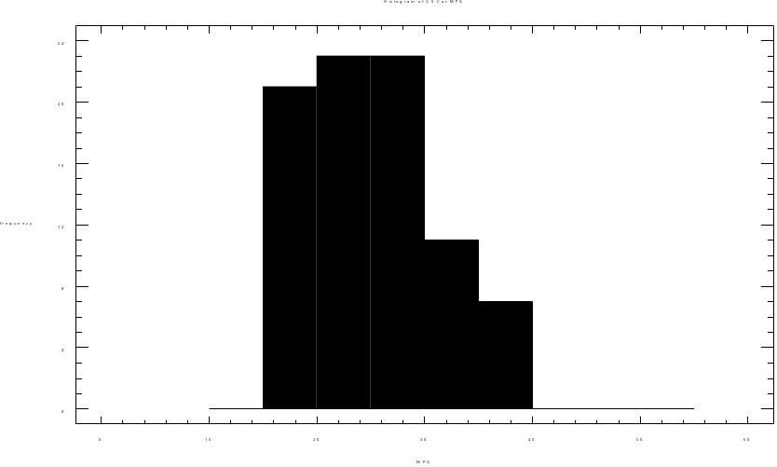

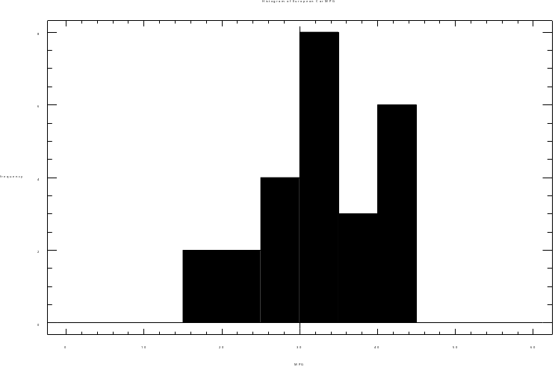

NOTE : To aid comparison the x -axis (the horizontal one) are all the same.

Construct the histogram for the Japanese cars.

List your observations that can be drawn from these displays. How can any differences be explained?



Another display, are cumulative frequency polygons or ogives, which are useful for ordering the data. These are formed by plotting the cumulated frequencies against the interval end points. For the car data they are shown below:

First For The U.S.A.
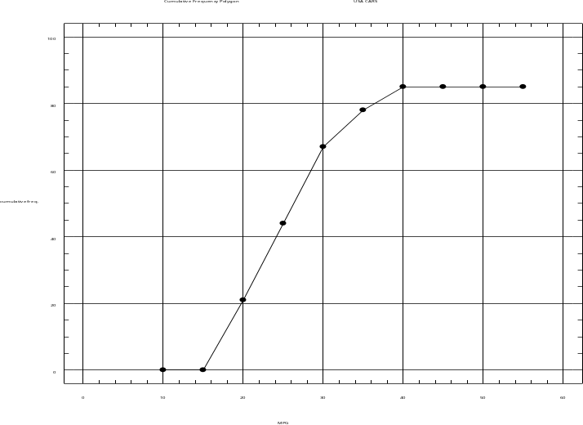

For European Cars

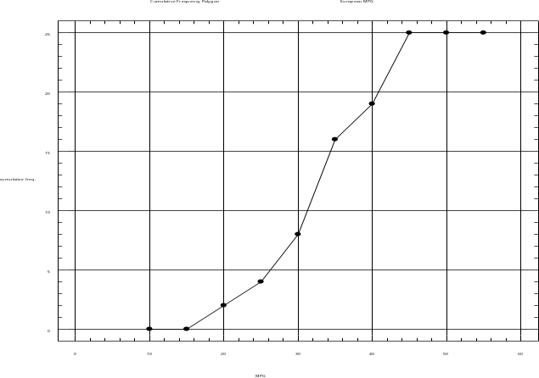
For Japanese Cars

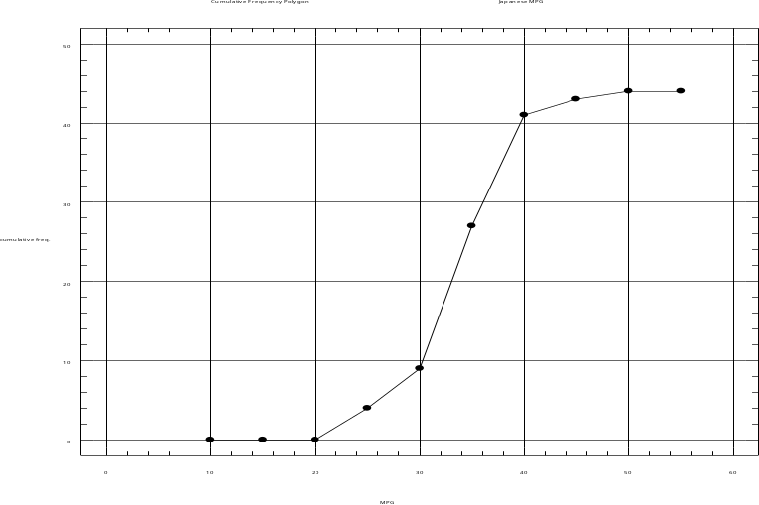

NUMERICAL MEASURES

LOCATION

The MEAN (or arithmetic average,) - this is just the sum of all the numbers divided by the number of numbers. It is written:

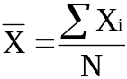

Where sigma means add up and Xi is a typical number and N is the number of numbers.

for example:

10 4 7 5 10 12 8
n = 7
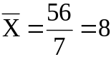

What happens to the average if the next number in the data series is 100?

The MEDIAN - this is the middle umber when the numbers arranged in order of size. For the above example:

4 5 7 8 10 10 12
|
|
Median

The mean can be changed markedly by extreme observations, if for example the next observation in the above series was 50, the mean now becomes 106/8 = 13.25 - not a very representative number. On the other hand the median is robust (insensitive) to such changes. That is :

4 5 7 8 10 10 12 50 (an even number so take the average)

9 (median)

Another measure is the MODE or the most common number.

For example:

2 4 7 3 8 3 9 1 2 3 4 8 3

mode = 3

Consider a consumer survey of Biscuit flavour, where consumers are asked to rate biscuits on a scale 1 (very disagreeable) to 9 very agreeable. The results presented on a DOTOGRAM might be :

. .
. .
. . . .
. . . . . .
. . . . . . .
. . . . . . . . .
___________________________________________
1 2 3 4 5 6 7 8 9

This is bimodal, with modes 3 and 8.

MEASURES OF SPREAD

The most obvious measure of spread is the RANGE which is simply the largest number minus the smallest. For example the range of the numbers :

2 10 13 20 4 7 8 9 9 3 25 20 10 6 6 4 8 10

is 25 - 2 = 23.

Just as the arithmetic mean was distorted by outliers (extreme measurements), so also is the range. Hence, alternative measures are required when outliers are likely to be present.

The most used measure the STANDARD DEVIATION. This measure is defined as the square root of the VARIANCE, which is a fundamental concept in statistics.

For present purposes the variance, denoted by s2 is thought of as the spread around the mean and is given by the formula:

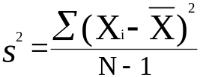

So the standard deviation is simply s.

To find the variance of the set of data measurements:

4 6 5 8 2 ; first find the mean.

Now subtract 5, the mean, from each number to get:

-1 1 0 3 -3

Next, square the numbers:

that is : 1 1 0 9 9

add them up to get 20

Now divide by n - 1, which is 5 - 1 = 4 to get 5 which is the variance, the standard deviation then is 2.236.

As with the mean and the range, the variance can still be distorted by outliers. Consider including 50 in the data set used earlier :

4 6 5 8 2 (50)

The variance and standard deviation now become 341.5 and 18.48 respectively. A more robust measure is the INTER QUARTILE RANGE.

To obtain this measure the data are arranged in order of size and then partitioned into four equal (or near equal) portions, that is:

2 4 5 6 8 50
| | |
| | |
| | |
Q1 Q2 Q3
(lower quartile) (upper quartile)
(median)

So the inter quartile range is Q3 - Q1 = 8 - 4 = 4 (by chance, it is also 4 if the 50 is not included).

Another often used measure of spread is the semi - inter quartile range, which is :

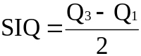

Coefficient of Variation (CV)

This combines the mean as a measure of location and the standard deviation. as a measure of spread to give a unit free measure.

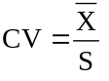

One normally desires this to be a large value, certainly bigger than six. For those with an electronics background it is analogous to the singnal to noise ratio.
Outliers

These are values that are not representative of the bulk of the data and as we will see later they can be detected as values that are more than three standard deviations away from the mean i.e.:
X_{i} is an oultlier if:

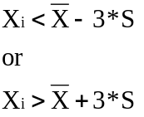

A simpler method of detection is to use the interquartile range i.e. Q₃-Q₁, which is called the hinge spread (HS). X_{i} could possibly be an outlier if it is below:

Q₁-1.5*HS or above Q₃+1.5*HS

X_{i} is probably an outlier if it is below:

Q₁-3*HS or above Q₃+3*HS

It is a good idea to scan data for outliers as they can give a false impression of the data when it is summarised. If the outliers looks to be a mistake of from a different population then it is usually removed (deleted).

The table below gives a numerical statistical summary of the mpg data for the different origins of the cars.

The findings from the pictorial analysis are verified.

Sample Average Median Mode Range
Level size
--------------------------------------------------------------------------------
U.S.A. 85 25.2624 24.3000 27.0000 23.5000
Europe 25 32.5520 33.0000 31.9000 28.1000
Japan 44 33.4795 33.3000 37.0000 25.5000
--------------------------------------------------------------------------------

Variance Standard Lower Upper
Level deviation quartile quartile
------------------------------------------------------------------
U.S.A. 37.4512 6.11974 20.2000 29.0000
Europe 66.9226 8.18062 28.1000 37.3000
Japan 27.8021 5.27277 31.4500 37.0000
------------------------------------------------------------------

NOTE: When comparing two processes at the same time robust measures are best, that is the median and inter quartile range. However, to monitor the same process over time, when one wants to pick up oddities the mean and range are best.

SKEWNESS

Skewness is a problem in statistics and occurs when a distribution of data has long "tails", for example production yields as a percentage of target or annual incomes of the working population, as shown in the diagrams below:

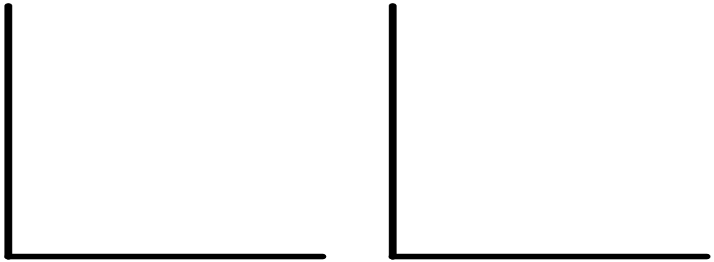
% of target annual income of population

Skewness can be measured by :

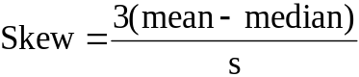

When skewness is judged a worry the mean and standard deviations are unreliable measures, the median and inter quartile range are better.

EXPLORATORY DATA ANALYSIS (EDA)

This is the name given to a very simple but powerful set of techniques that both visually and numerically describe sets of data.

Consider the following set of delivery costs:

40 38 27 39 36 37 33 31 30
55 59 52 28 36 38 34 35 38
63 52 57 38 26 31 36 60 84
44 41 39 37 37 29 52 38 42

These can be represented in a STEM & LEAF DIAGRAM as shown below:

Working Stem & Leaf
Stem Leaves
2* 7 8 6 9 Leaf Unit = 1
3. 3 1 0 4 1
. = 0-4 3* 8 9 6 7 8 5 8 8 6 9 7 7 8
* = 5-9 4. 0 4 1 2
4*
5. 2 2 2
5* 5 9 7 Leaves are the
6. 0 3 last important
6* digit.
7.
7*
8. 4 - Outlier?

Finished Stem & Leaf
Stem Leaves
2* 6 7 8 9 Leaf Unit = 1
3. 0 1 1 3 4
3* 5 6 6 6 7 7 7 8 8 8 8 9 9
4. 0 1 2 4
4*
5. 2 2 2
5* 5 7 9
6. 0 3
6*
7.
7*
8. 4 - Outlier?

Observations:

There are no delivery costs in the interval 45 to 49. Why?

NOTE : It is easy to obtain the mean and quartiles from this display. Since n = 36, Q1 will be between the 9th and the 10th number, Q2 (the median) is between the 18th and 19th number, and Q3 between the 26th and 27th number. They are:

Q1 = 34.5
Q2 = 38.0
Q3 = 48.0

NOTE: That unlike the histogram, the stem & leaf display preserves all the numbers.

From stem and leaf displays:

- outliers can be identified

- skewness can be identified

- gaps in the data highlighted

- other oddities - for example, the following stem and leaf is of the recordings of a patient's pulse rate:

4* 8 Leaf unit = 1
5. 22
5* 6666
6. 000000000044444444444
6* 888888888888888
7. 22222222222222222
7* 6666666666666666
8. 0000044444444
8* 88888
9. 222
9*
10. 0

Any comments on the above display?


Two stem and leaf diagrams can be compared back to back, for example American and Japanese car's mpg. This is a very useful display.

Back to back stem and leaf for U.S.A and Japan

U.S.A JAPAN

5 1F
7777766 1S
9999999988888 1o
1000000000 2* 1
333333222 2T 33
55544 2F 45
777777766666 2S 77
99888888 2o 99
11000 3* 1111
322 3T 22222222233
544444 3F 4445
666 3S 66677777
988 3o 88899
4* 0
4T
4F 4

HI 46

The individual stem and leaf diagrams for all the countries are shown on the next page.
Stem-and-leaf display for European Car MPG: unit = 1 1|2 represents 12

2 1o|67
4 2*|01
8 2o|5789
(7) 3*|0011344
10 3o|5667
6 4*|013344

Stem-and-leaf display for Japanese Car MPG: unit = 1 1|2 represents 12

LO|21

3 2T|33
5 2F|45
7 2S|77
9 2o|99
13 3*|1111
(11) 3T|22222222233
20 3F|4445
16 3S|66677777
8 3o|88899
3 4*|0
2 4T|
2 4F|4

HI|46

Stem-and-leaf display for USA Car MPG: unit = 1 1|2 represents 12

1 1F|5
8 1S|6677777
21 1o|8888899999999
31 2*|0000000001
41 2T|2223333333
(5) 2F|44555
39 2S|666667777777
27 2o|8888899
20 3*|00011
15 3T|223
12 3F|444445
6 3S|666
3 3o|889

Digiplots

These combine the idea of stem and leaf displays with run plots and are useful to reflect the distribution and time series.

Consider the following twenty test scores:

80 85 90 70 75 80 82 73 79 70
50 55 58 59 60 50 53 56 54 50

0 9
5200 8
95300 7
0 6
986543000 5

BOXPLOTS

These are excellent displays of both location and spread and they are very easy to do, especially if the stem and leaf has been done. Consider the delivery cost example:

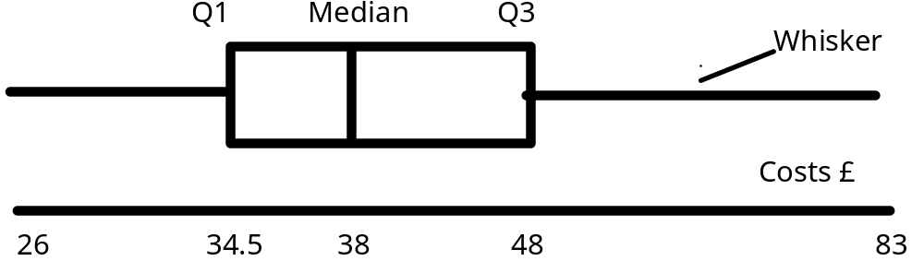

The box contains 50% of the data , so it's width is a reflection of spread, location is shown by the median and skewness by the symmetry of the box.

Boxplots are good for comparing several samples. for example a comparison is quickly made of the mpg of cars from different origins in the diagram below:
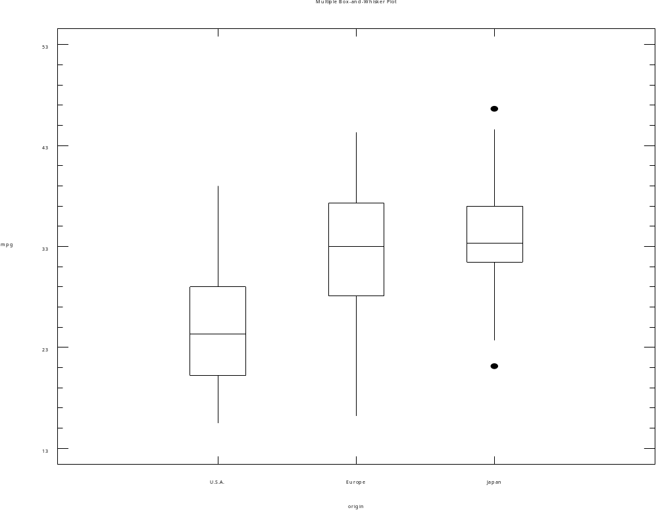

This verifies the earlier findings.

Consider steels sheet being rolled to a target thickness (T) on four different machines:

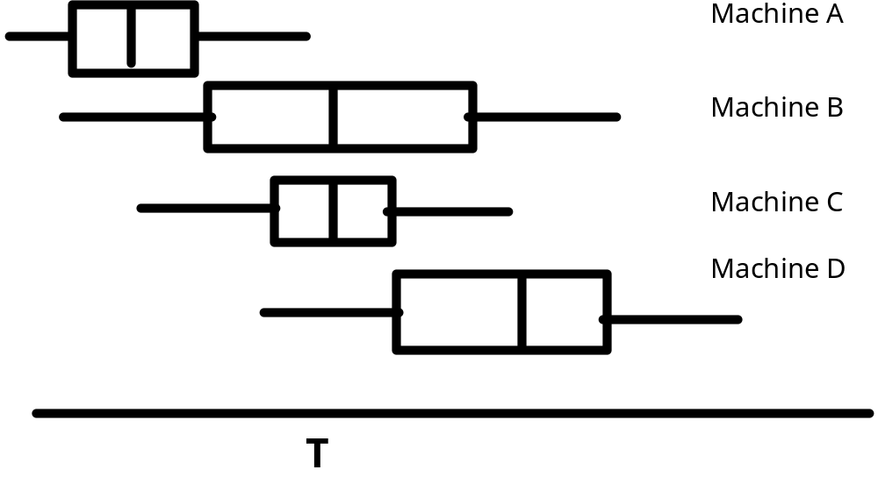

From this display, one observes that:

- Machine A is located well below target relative to the other machines.

- Although on target, machine B displays a great deal of variability relative to the other machines.
- Machine C appears ideal

- Machine D is located too high.

